Android jChat

User Guide

# Introduction

jChat application is an agent based IM-style application for Android , based on JADE (jade.tilab.com).

It allows the user to communicate with any other contact having the same software running and connected to the same JADE platform. Users can send text IM in a chat like way, call a contact by phone or even send an SMS to a contact.

Moreover the position of each contact can be seen on the map at any time and it is continuously updated.

# Using Android jChat

## Connecting to JADE

The first step for using jChat is the connection to a JADE Leap main container running on a host machine (local or remote). The default host machine and the port for the main container are specified on strings.xml file during compilation (this is the default value).

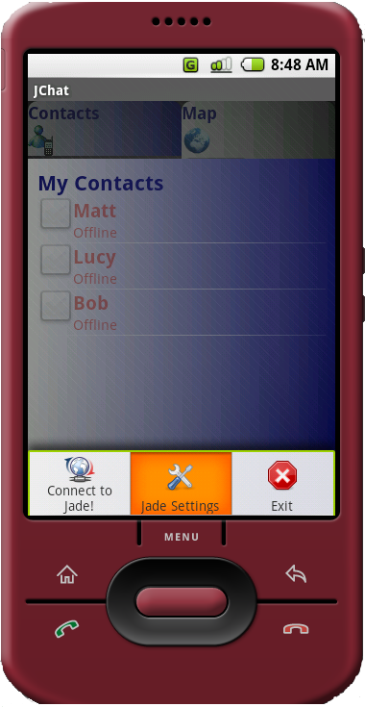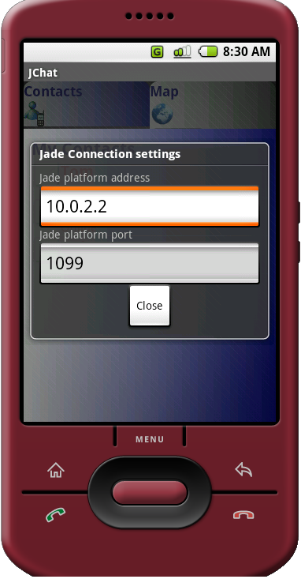

To change these settings perform the following steps (see Figure 1):

1. Press the ***MENU*** key on the emulator
2. Choose ***Jade Settings***
3. Insert the needed settings (***hos****t* and ***port***). Remember that the localhost address on Android emulator is 10.0.2.2
4. Press ***Close*** button
5. Press the ***MENU*** key on the emulator
6. Choose ***Connect to Jade!***

If the connection to Jade platform is successful you should be able to see the new agent running on Android emulator into Jade Remote Agent Management GUI.

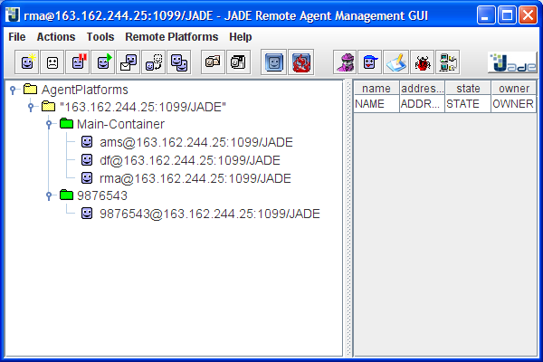

The name of the new agent should be the same as the phone number of the phone.

# Knowing jChat tabs

The main screen is divided into two different tabs, providing contacts information in different visual ways.

## The Contact tab

## contacts-tab.png

The contact tab contains a list of all currently available contacts.

Any contact can be online (connected to our JADE Leap platform) or offline.

Online contacts are shown in blue, while offline contacts are shown in red.

For each online contact the distance in km between the phone owner and the contact is shown.

## The map tab

## map-mode.pngsatellite-mode.png

The map tab shows the position of each online contact on a map and continuously updates their position.

Each contact is visible as a pin of different colors: the phone owner can see his own position as a yellow pin, while others contacts are shown as blue pins.

Maps can be seen both in traditional map mode and in satellite mode: the user is able to switch between the two modes using the switch button placed right above the map.

# Picking contacts

To be able to communicate with others, users must first select contacts (“picking”).

You can pick one or more contacts in both contact tab and map tab.

In contact tab, you have to click on the checkbox beside each contact. In map tab you simply click on the pin representation of the contact.

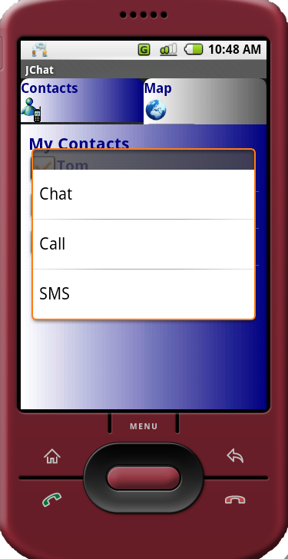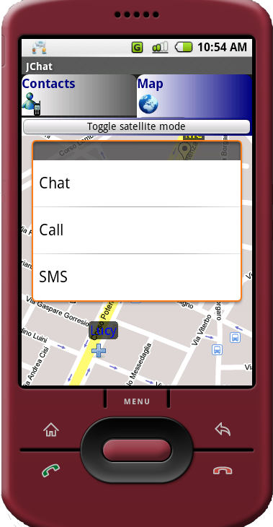

Please note that contact selection is local to the map (you cannot begin selecting contact in a tab, then switch to the other tab and continue selection).

After contacts selection, you can decide how to interact by pressing for some seconds the emulator selection button and choosing the desired option from the context menu that will popup.

# Interacting with contacts

Users can communicate with contacts in three ways: SMS, phone calls or chat sessions.

## Sending an SMS to one or more contacts

After choosing to send an SMS message, user will be redirected to the SMS sending screen. Obviously a message can be sent to more than one contact at the same time.

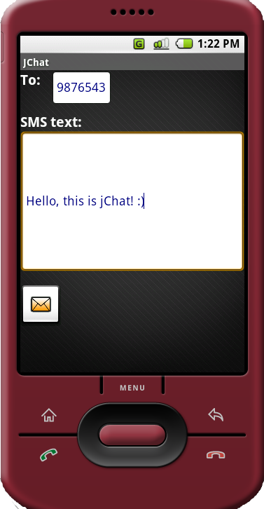

Here he will be able to enter the message text and to send it.

Message shall be split into chunks if too long and sent to the desired contact/s.

Please note that at the moment the emulator does not support SMS sending emulation, so nothing shall be received. The SMS sending process is mocked and it always succeeds.

## Calling a contact

If you choose to call a contact, the calling screen shall appear and the call shall start.

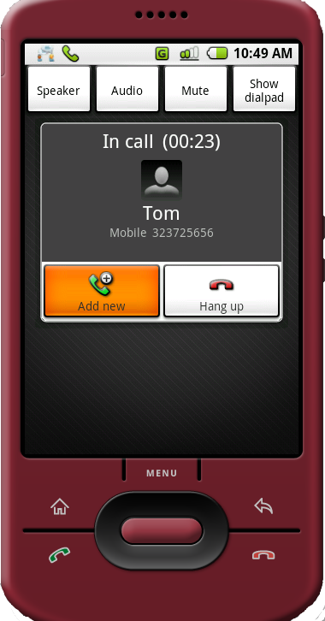

Obviously, the phone call is totally mocked.

If you try to call more than one contact at the same time (by selecting many contacts and choosing ***Call*** from context menu) a message shall appear warning that only one contact can be called at the same time.

## Starting a chat session

We define *chat session* as a group of two or more contacts talking together.

A chat session can be started by the phone owner (by selecting contacts and choosing ***Chat***from the context menu ) or by another contact that wants to talk with the phone owner himself.

If the user chooses to start a chat session, the chat screen shall appear. In this screen you will be able to see the list of the other session participants, to enter a text message, to send it and to see a list of all the conversation messages with timings. A persistent notification shall also be added on Android status bar.

Whenever a message is received, a toast notification is shown and a persistent notification is added to the status bar. The user that receives a message from another contact is able to jump to the chat screen by choosing the corresponding notification on Android status bar (in particular you have to drag down the bar and click the notification).

In this way the user can switch between many different ongoing conversations by using the status bar. Each time a conversation notification is selected the chat session is redrawn.